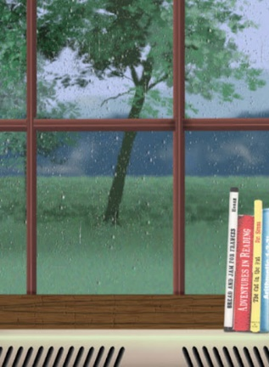
The Game

Danny and Susie were bored. It was wet play again and it felt like they hadn’t seen the playground for weeks. Rivers of greasy rain streaked the classroom windowpanes and pooled to make gigantic puddles in the centre of the netball court.
Another lunchtime inside was clearly stressing Mrs Allbright, as she seemed to be tense and a bit more snappy than usual. She sat at her desk with a steaming cup of tea and marked books with the ferocity of a wild beast.
To top it all, every good game was being used and only the tub of dominoes was left. Everyone knew that half of them were missing and the other half had been chewed by the school ‘Reading Dog’.
Danny and Susie searched the classroom for something to do. To their dismay, the comic box was empty, the iPads had been snapped up by Freya and her gang and Billy seemed to have started a resurgence of the game Slap, which didn't look like fun at all.
As the two friends squeezed past the art table to get to the wet-play books, a tatty, cardboard box fell from the top shelf of the bookcase. Susie picked it up. “I’ve never seen this game before,” she said, wiping the dust from the unusual lid. It was embossed with intricate patterns and around the edges were pictures of animals, insects and other strange creatures.
“An animal game? Boring!” said Danny, already losing interest.
“Oh come on, let’s play. There’s nothing else to do,” suggested Susie, smiling widely and shaking the box. They sat down in a quiet corner, lifted the lid and took out the board.

