Amazing Alaska

Day 1 -Anchorage city tour
On this tour you can see the city of Alaska on a cable car for one hour. In this time you will be able to see the hidden parts of Alaska .Sit back and relax while the historical guides will teach you about the history of Alaska Also you may stop for lunch at the best tower café giving you another opportunity to see the superb view.
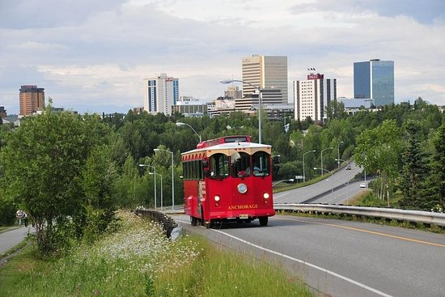

Day 2 –dog sledding
On the sledge you will go down five miles of snowy trails. At the end of the trail you will be able to hug the huskies. At the end you will be able to drink a hot chocolate and a conversation about whatever you want in a warm hut just have for your private group.
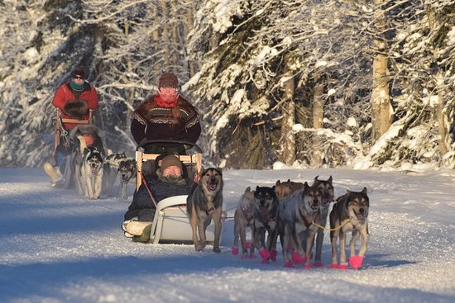

Day 3-Matanuska Glacier Winter Tour
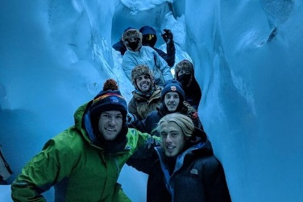
On this tour you will receive a free coat as it will be freezing. You will have a guide which will show you through the ice tunnels. You will be in the tunnels for an hour. You can see ice and snow sculptures.

Day 4 - whale watching
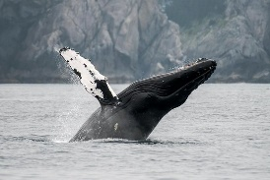
On this watch you will be given a pair of binoculars to help you search for whales. You will be held on a boat for 1hour and 15 minutes. You might be able to play a game called who can spot the most whales.

Day 5 -Northern Lights and Chena Hot Springs Tour from Fairbanks
On your last day you can relax in your cabin until night when the northern lights take place. You will see patterns of plenty and ice sculptures of every animal enjoy your wonderful holiday in Alaska.
