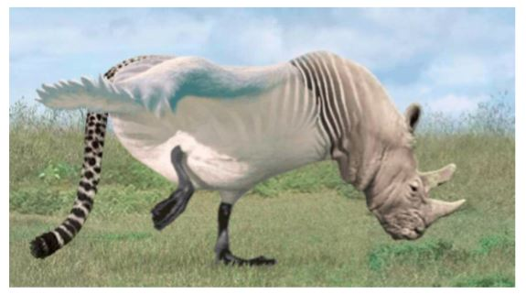
The Rhiswanozebtah
An information text
by Ted Splorer

The Rhiswanozebtah is an extremely rare, flying creature from the subfamily Rhinofelinae.

Rhiswanozebtahs, although uncommon, are easy to identify, as they are a mixture of four distinct animals. They have the head of a rhino, the body of a swan and zebra and the tail of a cheetah. They have a wingspan of 2.8 metres and can grow to over 5 metres in length, which means they are the largest flying creatures since Pterodactyl dinosaurs. Additionally, their skin tends to be covered in feathers but as they get older, the zebra stripes become more prominent. Their tails are covered in fur and their heads are covered in leathery, grey skin. However, juveniles are born completely bold and develop their fur, feathers and colourings when they mature.

Most Rhiswanozebtahs are found across South Africa, although some have been known to inhabit the deepest rainforests of Venezuela. Amazingly, Rhiswanozebtahs like to burrow and therefore make their homes underground. They use their Rhino tusk to gouge the sun-baked soil and tunnel deep down, to create soil cocoons to sleep in. Some have been known to sleep in trees, but only the largest Kapok branches can support their enormous weight.

All Rhiswanozebtahs are carnivores and only eat meat. Interestingly, their favourite prey is the Springbok antelope, which they descend on from great heights and then wrestle to the ground. They have also been known to devour many smaller mammals such as African Wild Cats and aardvarks. Furthermore, many will guzzle gallons of water a day and sadly, these creatures can cause huge water shortages during the dry season.

As well as being the largest flying animal in the world, the Rhiswanozebtah is also the most talented. The majority can use their vocal cords to create the most beautiful morning chorus as the sun rises. This is with the exception of the young males. Their voices do not develop until they are 15 years old and some explorers have reported that their calls are high-pitched, squeaky and very unpleasant to listen to. In addition to this, and despite their size, all Rhiswanozebtahs are tremendously agile. They can stand on one leg for long stretches of time, roll and flip whilst running or flying and can balance on narrow branches and cliff edges when surveying for prey.

For many years, scientists have been secretly tracking the Rhiswanozebtahs in the wild and now know that there are only approximately 625 roaming the savannahs and nesting in rainforests. Amazingly, however, there have been rare sightings in other parts of the world, so just maybe, the Rhiswanozebtah will be spotted in a neighbourhood near you in the not-so-distant future.

